**Salesforce Bulk API 2.0**

1. Bulk API is based on REST principles and is optimized for working with large sets of data. You can use it to insert, update, upsert, or delete many records asynchronously, meaning that you submit a request and come back for the results later. Salesforce processes the request in the background.
2. In contrast, SOAP and REST API use synchronous requests and are optimized for real-time client applications that update a few records at a time. You can use both of these APIs for processing many records, but when the data sets contain hundreds of thousands of records, they’re less practical. Bulk API’s asynchronous framework is designed to make it simple and efficient to process data from a few thousand to millions of records.

**Create a Bulk Job**

1. In workbench, Select POST request.
2. URI = /services/data/vXX.0/jobs/ingest,
3. Request body:

{

"operation" : "insert",

"object" : "Account",

"contentType" : "CSV",

"lineEnding" : "CRLF"

}

1. Content type – application/json

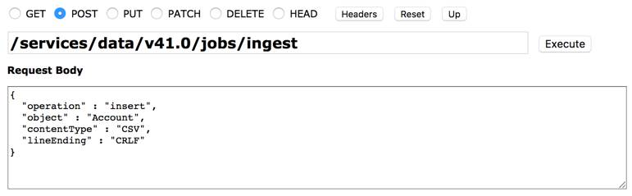

It will create a job in system. Return response will be like

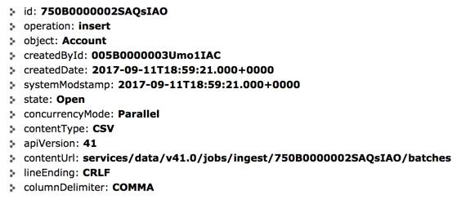

## Add Data to the Job

1. Use PUT method
2. URI = /services/data/v XX.0/jobs/ingest/jobID/batches
3. Content type – test/csv
4. Body

"Name"

"Sample Bulk API Account 1"

"Sample Bulk API Account 2"

"Sample Bulk API Account 3"

"Sample Bulk API Account 4"

## Close the Job

Once you are done with sending data, it’s time to close the job and let Salesforce know that it’s time to process the data. Do this by changing the job state from Open to UploadComplete.

1. Method = PATCH
2. URI = /services/data/v XX.0/jobs/ingest/ jobID
3. Content type – application/json
4. Body

{

"state" : "UploadComplete"

}

## Check the Status of the Job

1. Method : GET
2. URI : /services/data/v XX.0/jobs/ingest/ jobID

If your state is still **UploadComplete** instead of **JobComplete**, Salesforce is still processing the job.

## Get the Job Results

1. Method : GET
2. URI for success records: /services/data/v XX.0/jobs/ingest/ jobID/ successfulResults

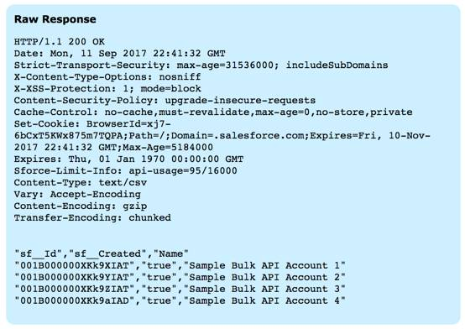

1. URI for failed records: /services/data/v XX.0/jobs/ingest/ jobID/ failedResults



Salesforce returns a CSV that contains a list of all the records in the job that were successfully/failed to processed.

